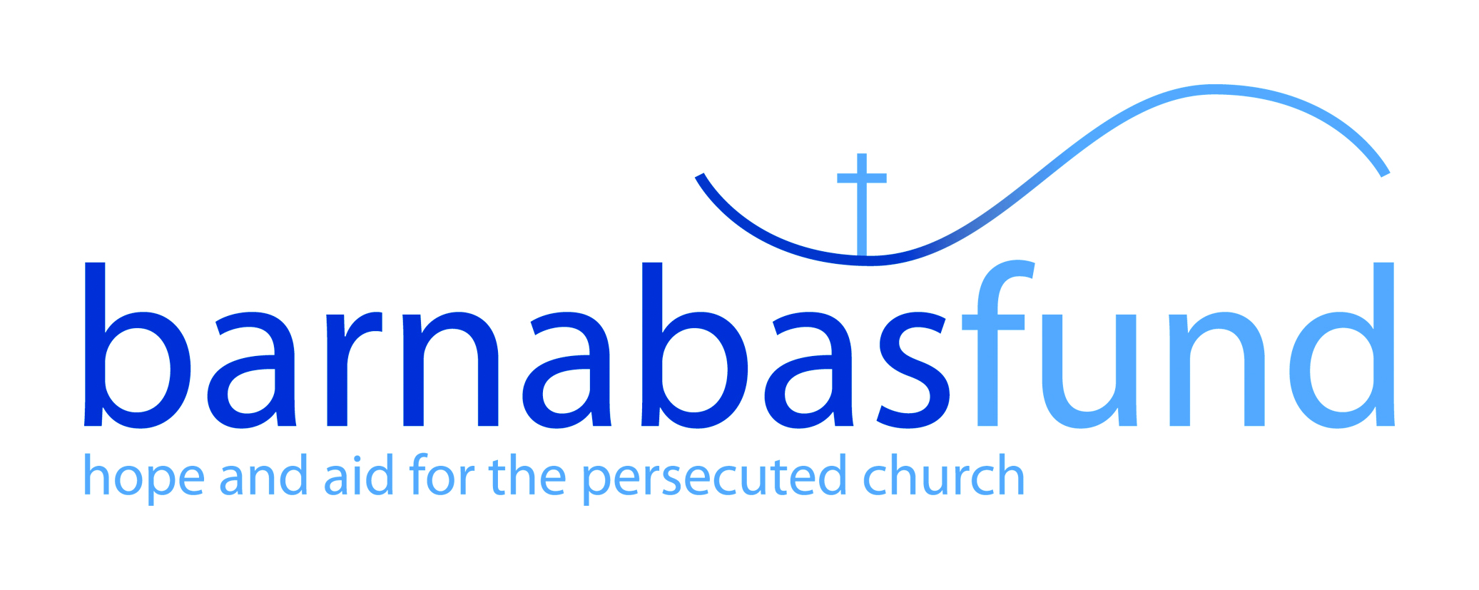

Application Form
for Summer Internship

Which area are you interested in:
In order for your application to be considered it is important that this application be completed in full. An incomplete application will not be considered.

How did you hear about this internship?
Please tell us why you have applied for this internship? (This is your opportunity to tell us about yourself and what drew you to apply, please continue on separate sheet)

Personal Details
Forename: | Surname:
Address: | Email:
 | Home Telephone:
 | Work Telephone:
 | Mobile telephone:
Post Code: | Please confirm if you are happy for us to contact  you on the above: Yes No

Training and Development

Please give details of training courses you have attended which are particularly relevant to this role. Please start with the most recent course first. Please continue on a separate sheet if necessary.

Tell us about any training you’ve done: | Date Completed

Interested in IT, tell us a bit more:
IT Package/Training: | Level achieved:

Personal Faith
We desire that all applicants be committed Christians, and similarly, be committed to the Christian values and ethos of Barnabas Fund. Therefore, please tell us something of your faith and Christian experience. Please continue on separate sheet.
Please give the name and address of the church you attend:

General/Additional Information
Please provide us with any additional details, you feel are relevant to support your application. This may include additional skills, knowledge or experience not mentioned in the previous sections. Please continue on a separate sheet if necessary.

Reasonable Adjustments
Would you like us to make any specific arrangements to facilitate a fair interview due to a disability? For instance, do you need a wheelchair-accessible office?

Other Information
Do you have any holidays booked?
Two character references from a friend and your church leader will really help us get to know you more: | - Name, contact number and email address of reference you will use to attest to your work ethic and character. (Must be a person not related to you):  ______________________________________________________  - Name, contact number and email address of church pastor / elder:  ______________________________________________________

Data Protection

*The information provided in the application form will be processed in accordance with current data protection regulations.
We may verify information you supply to obtain employment by consulting a third party or statutory agency at any time. We may provide information from your application to appropriate third parties (e.g. HMRC).
*If you are unsuccessful in this application, we can hold your information on file in case of future vacancies. Instead of securely shredding it, we will retain it securely for an additional 12 months. You must specifically authorise this below.
Right to Work in the UK

You will be required to provide the appropriate official documents to confirm your right to work in the UK if you are offered an interview. Do you currently have the legal right to live and work in the UK:
Yes No

Declaration

I authorise you to contact the disclosed references to support this application.
I consent to the processing of data supplied in this application form for the purpose of recruitment and selection.
I confirm that the above information is correct. I understand that providing false or misleading information to secure employment is misrepresentation. My application may be rejected or internship terminated in such circumstances.
Signature: ……………………………………………… Date: ……………………………
* Where your application is unsuccessful this form will be securely shredded at the end of the process. We are happy to keep this information confidentially on file for 12 months in case of further vacancies. Please sign the authorisation below if you wish us to do so.
I authorise you to retain my application and associated personal information for up to 12 months from the date below.

Signature: ……………………………………………… Date: ……………………………

